Add Static IP Service

Version Control:

Use Case Name: |  | Add Static IP Service
Use Case Owner: |  | Sumit Borade
Current Version |  | 0.1
Use Case Version History
Modified Date | Version |  | Modified By | Change Description
October 28,2009 | 0.1 |  | Sumit Borade | Initial Version

Brief Description:
This use case describes the process by which a YouSee subscriber orders a change to their broadband services and how the service is changed.

The use case is written from the perspective of the SMP provisioning solution.

Related Documents
- YouSee SMP SOW2Architecture Requirements Document
- YouSee SMP SOW2 Business Requirements Document
- Voice over Cable Use Case Activation
- Cisco BACC TC Specification
- CISCO Subscriber Manager TC Specifications

Related Use Cases

Pre-Conditions
- Subscriber has a Cable Broadband Plan

Post-Conditions
- The IP address assigned to the Standard CPE is Static.

Use Case

Primary Flow Diagram
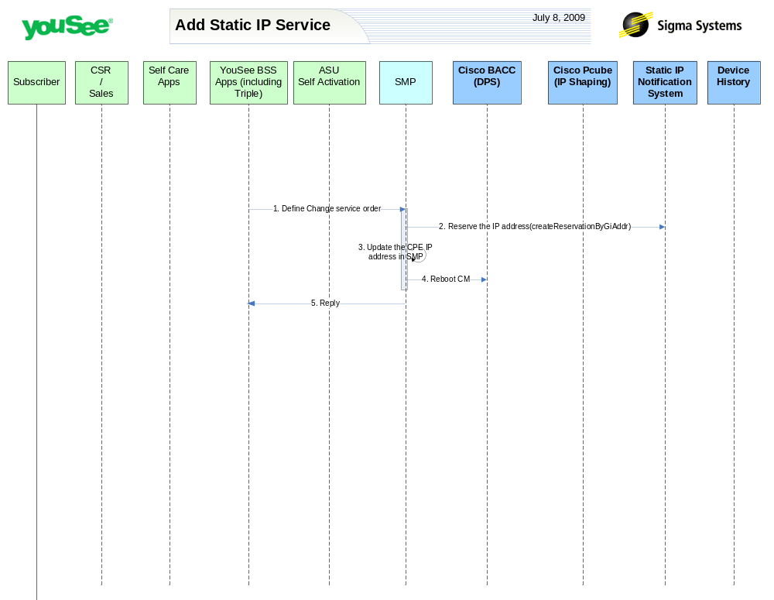

Primary Flow Detail
# | Actor: Key Action | Description | Alternate Flows/Details
 | YouSee BSS: Order is communicated to SMP to provision Static IP address | YouSee BSS (Triple) will communicate the order to SMP through SMP’s Order Management API. Triple will provide logical services and service attributes. SMP will be required to translate these service/service attributes to engineering level resources and resource attributes.
 | SMP: Provision static IP Service | SMP will change the Dynamic IP address assigned to the Computer to Static IP address.  SMP will provision static IP Service on YouSee Internal Static IP Notification System. Internal youSee static IP notification system will provision the CISCO DHCP Server by selecting the IP address looking at the IP Scopes for the CMTS and will return SMP the reserved static IP address
 | SMP: Update Static IP Address in SMP System | The static IP Notification system will return the reserved IP address to SMP and will SMP will update the IP address in its data base.
 | SMP: requests BACC to reboot the CM Device | SMP will then request BACC to reboot the CM device resulting in the CM getting the new configuration, MTA to go offline and CPE to be assigned a new public IP Address.
 | SMP: Replies back to ASU the status of Activation | SMP will reply to ASU the status of Provisioning Order to ASU. | If Provisioning fails then SMP will put the Failed task in Manual Queue.

